**1971** continued: This is a special entry:

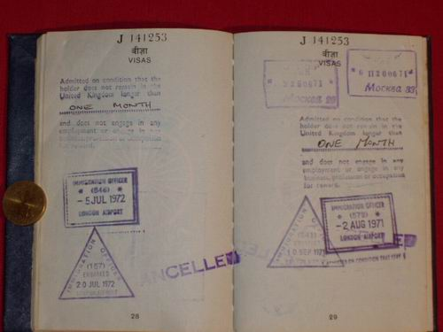

top right: Srila Prabhupada's entry and exit stamps from his one and only historic visit to Moscow

The entry is **20/06/71** and the exit is **25/06/71**

ХариШори дА, 21.02.2010